**User Manual content on Inter Unit Communication Functionality**

Inter Unit communication functionality is now made available in Faceless Penalty for communication between various units in faceless manner. The communication between various units i.e. Assessment Unit (AU), Review Unit (RU), Technical Unit (TU) would be done through National Faceless Assessment Centre (NaFAC). NaFAC users will also be able to communicate to users from other units i.e. AU, TU & RU. Communication can be done by logged on user at the same level i.e. AO of **Assessment Unit** can communicate with AO of other units i.e. **Review Unit, Technical Unit** likewise **Range** to **Range** or **PCIT/CIT to PCIT/CIT** or **CCIT** to **CCIT** or **PCCIT** to **PCCIT** in various units.

The functionality is now available for AOs and Range Heads in all the above mentioned units i.e. AU, TU & RU. NaFAC AOs will be able to communicate with AOs in other units, similarly for other NaFAC users at same level.

**Note:** Communications under this functionality shall not be part of case history noting in case work item. Therefore, this functionality may be used primarily for reminders or other communication etc and not for making references or for other processes for which there are specific functionalities in ITBA.

Steps for communication b/w different units are as below:-

* **User: Source Unit AO**

1. Navigate to ITBA Portal 🡪 **Penalty**
2. Under **Menu** 🡪 Click on **Inter Unit Communication**

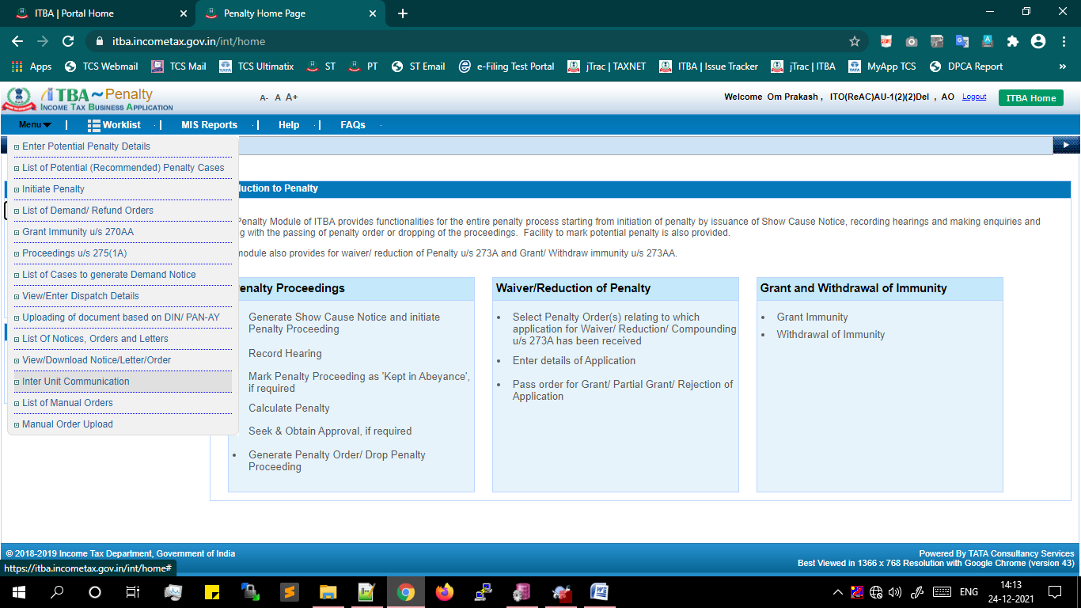

**Inter Unit Communication** initiation screen will be available to user.

**Proceeding Type** will be auto-selected and disabled as **Penalty.**

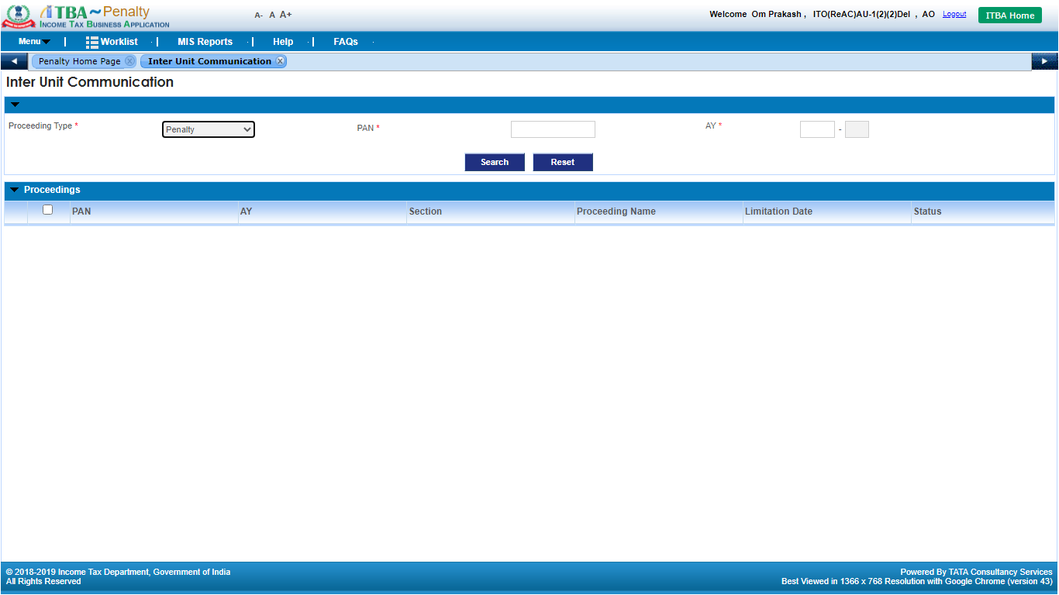

1. Enter the **PAN and AY.**
2. Click on **Search button.**

The **Pending proceedings** related to that **PAN** and **AY** will be displayed on screen.

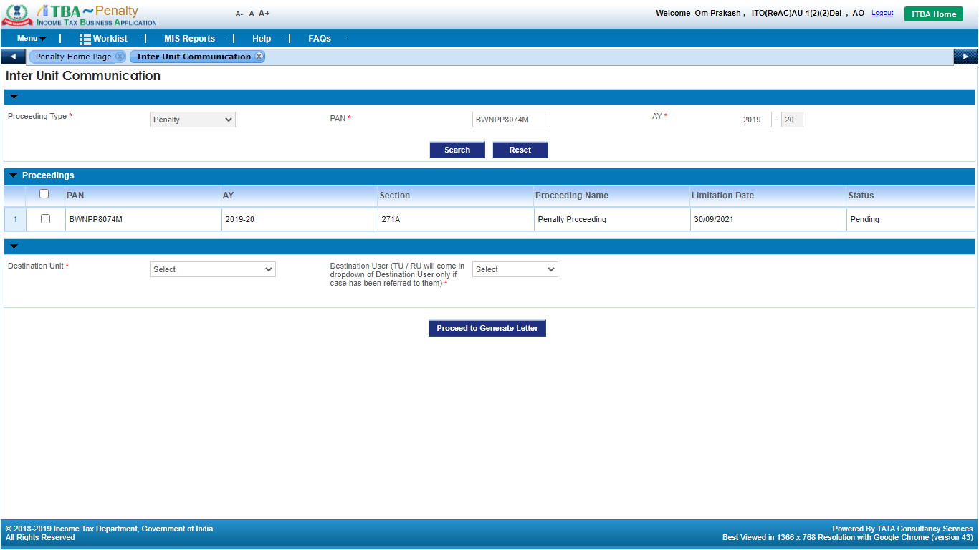

Note: Currently only **Pending proceedings** related to the **PAN** and **AY** will be available for selection.

1. Select the proceeding against which Inter Unit Communication functionality needs to be exercised.

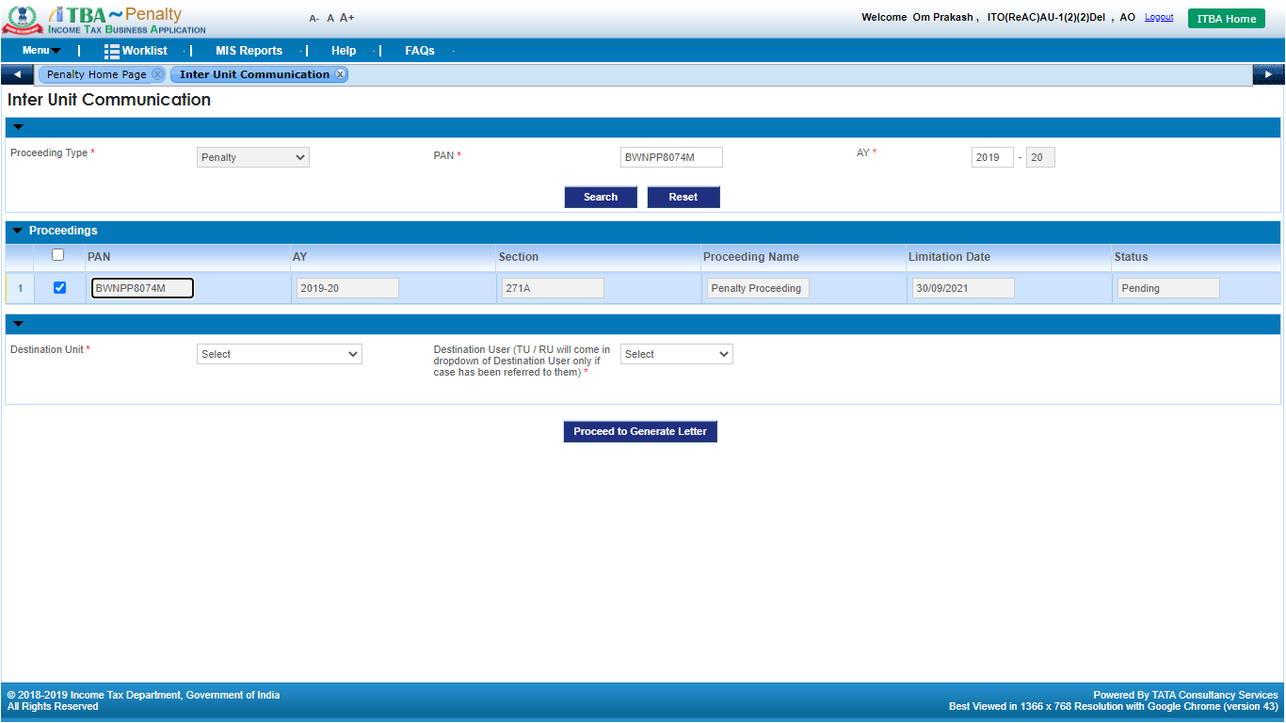

1. Select the **Destination Unit**. ( Logged on user’s unit will not be displayed in the dropdown)

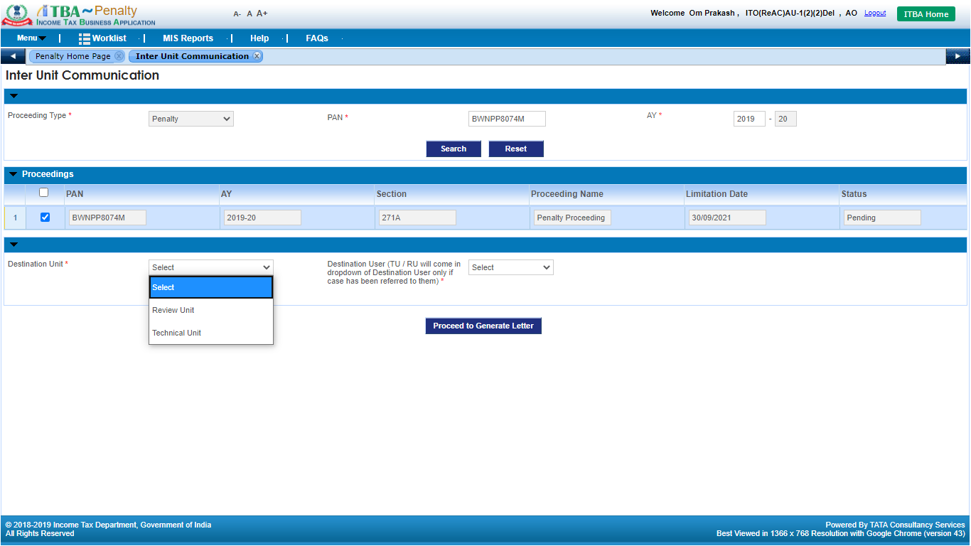

1. Select the **Destination User**. (Note: TU / RU will come in dropdown of Destination User only if case has been referred to them)

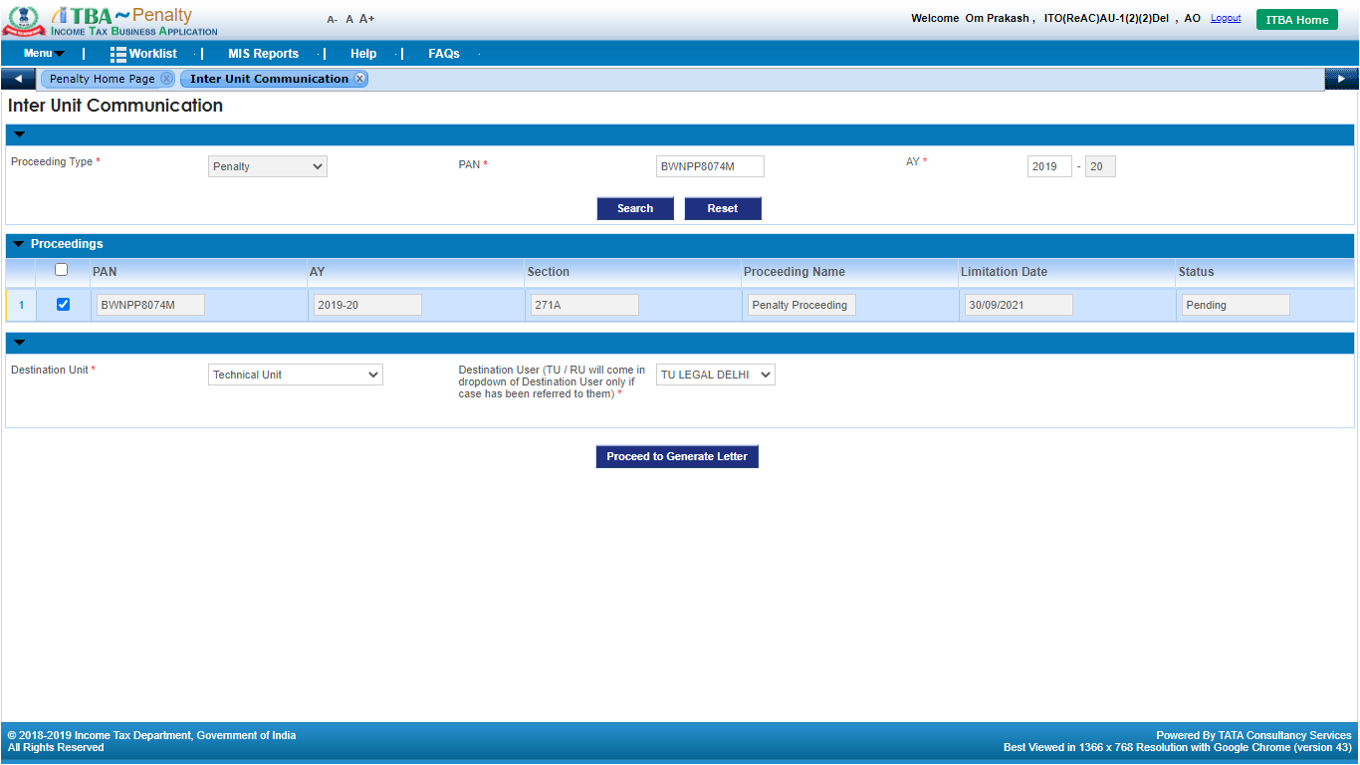

1. Click on **Proceed to Generate Letter** button.
2. Enter the text to be printed in the letter.

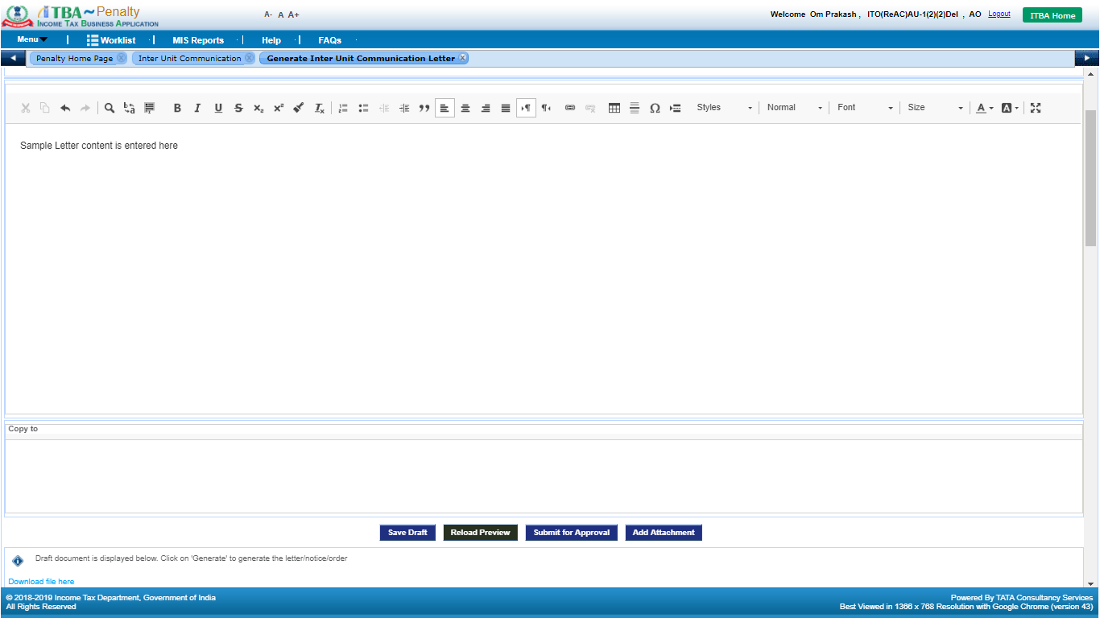

1. Click on **Save Draft** button to save the details in the system.
2. Click on **Reload Preview** button to view the draft Letter.
3. User can attach supporting attachment along with Communication Letter by clicking **Add Attachment** button provided on screen and uploading the supporting document.

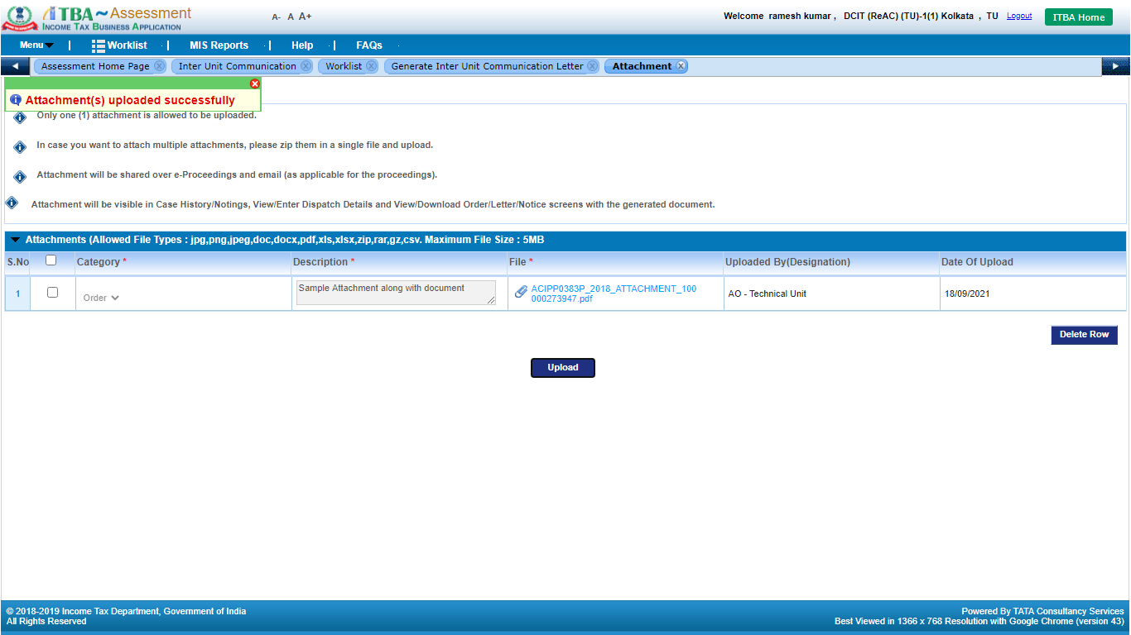

1. Click on **Submit for Approval** button to submit the draft request for approval to Range user. Success message will be displayed to the user regarding the request is successfully sent to Range user for necessary action. A child workitem is created in the worklist of Range.

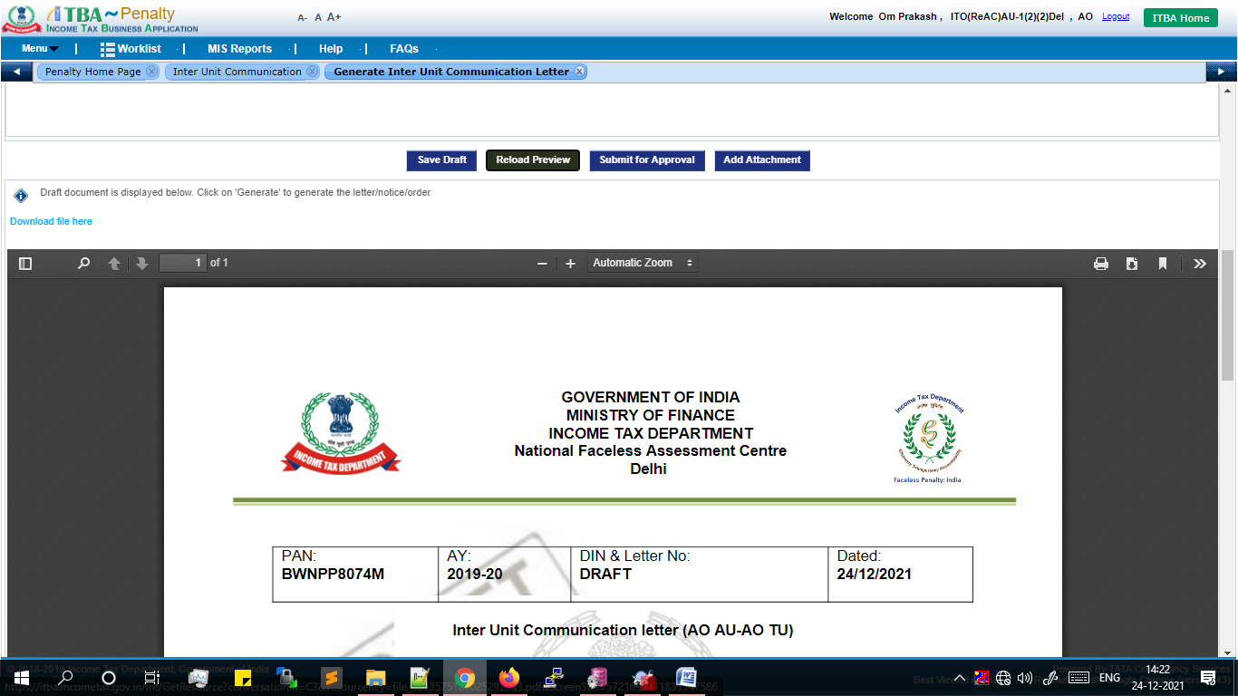

**Note:** Approval is not applicable for generation of Communication Letter for **Range Head** and above users i.e. **PCIT, CCIT & PCCIT**.

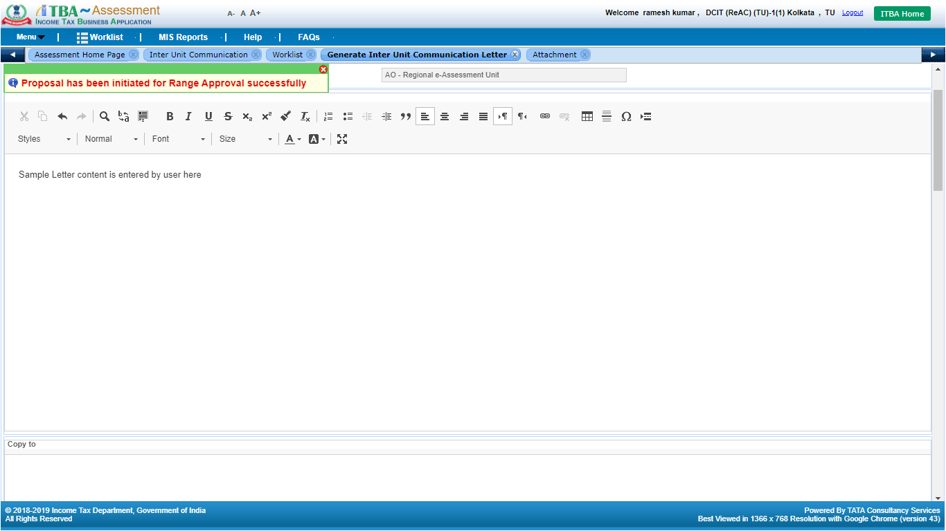

* **User: Source Unit Range**

By default, all the cases pending for approval with Range are listed in the Worklist of the Range.

1. Navigate to **Penalty** module.
2. Under **Menu** 🡪 **Worklist**
3. Click on **Subject** link. Inter Unit Communication Details child workitem screen will be displayed to the user.

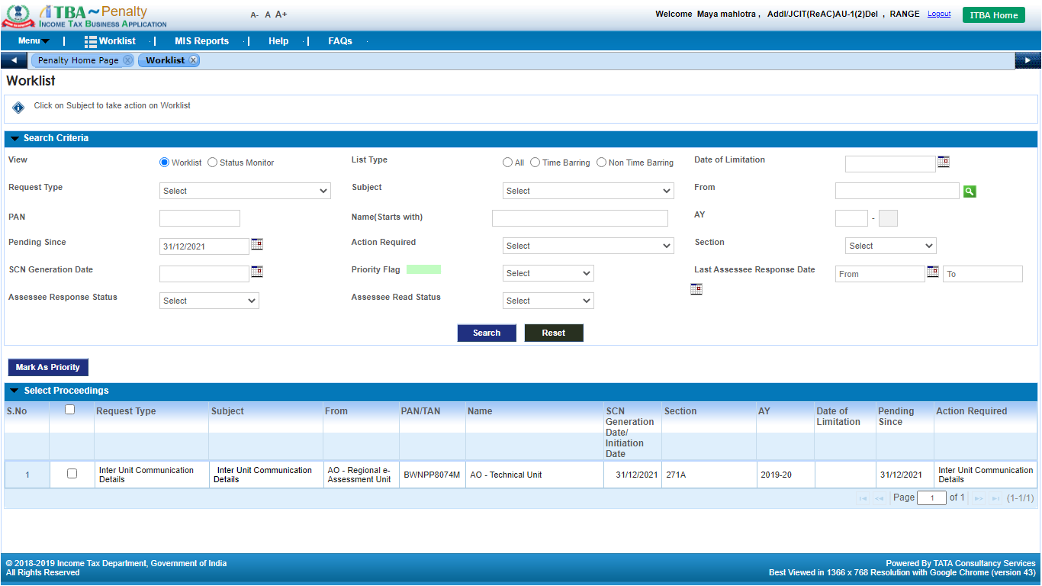

1. Click on **Inter Unit Communication Details** button to view the draft communication Letter. User can view / edit the content of the letter

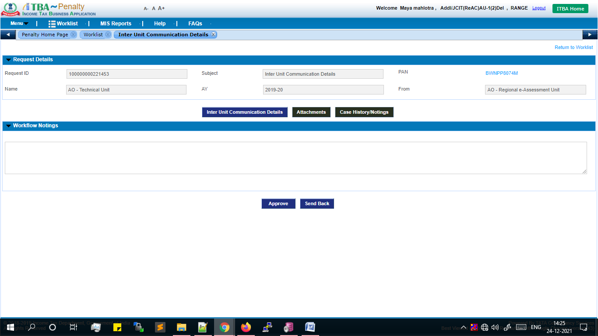

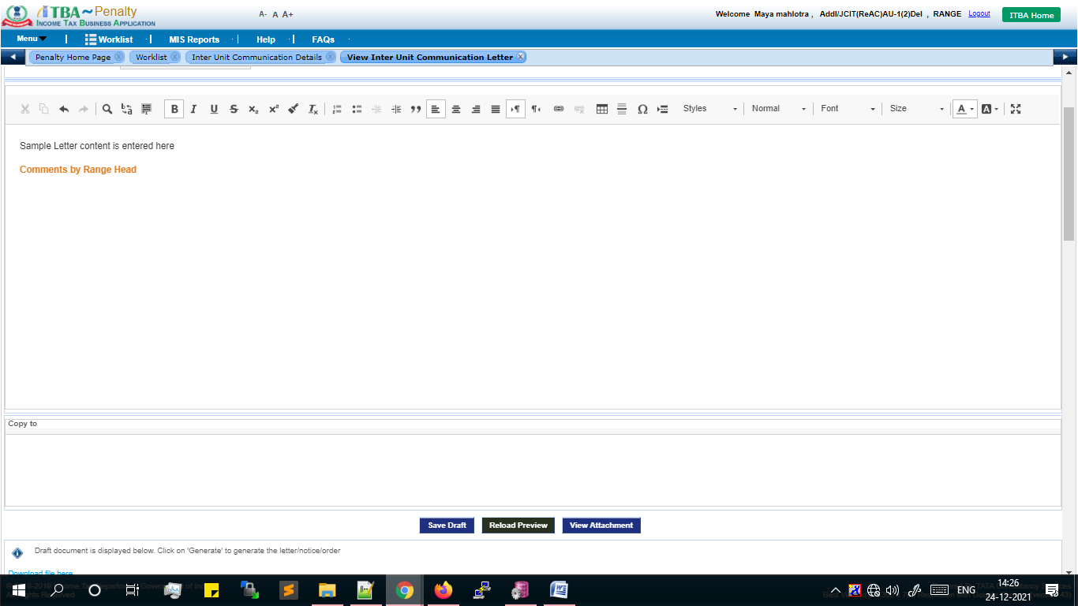

1. Range can take any of the 2 options:

* **Send Back**: In caseany clarification is required or letter content is required to be edited through AO, Range will enter remarks in **Workflow Notings** andClicks on **Send Back.** The workitem will be available to AO. AO will do the necessary changes or provide clarification and **Submit** back to Range.
* **Approve**: In case no updates are required, user will be able to approve the generation of Communication Letter in ITBA system. Enter remarks in **Workflow Notings**. Click on **Approve** button. The Communication Letter generation request is approved by Range user and child workitem will be available to AO user to proceed with thegeneration.

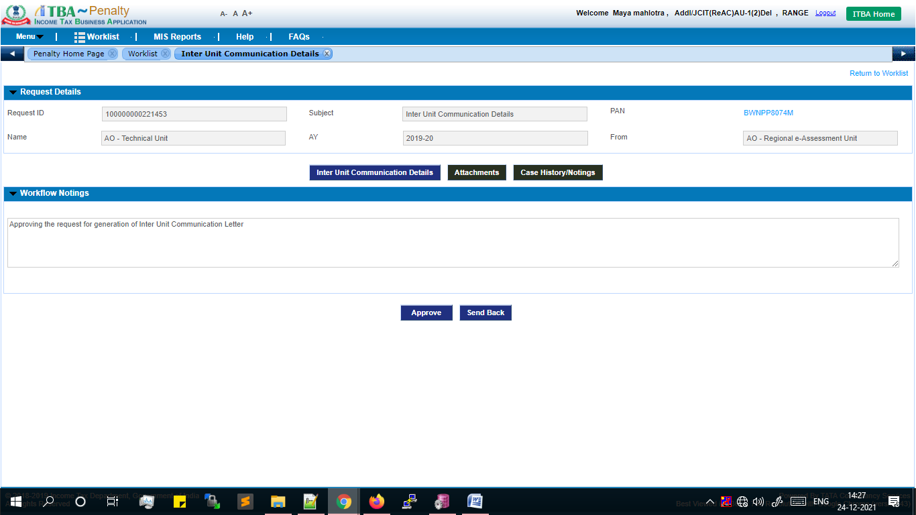

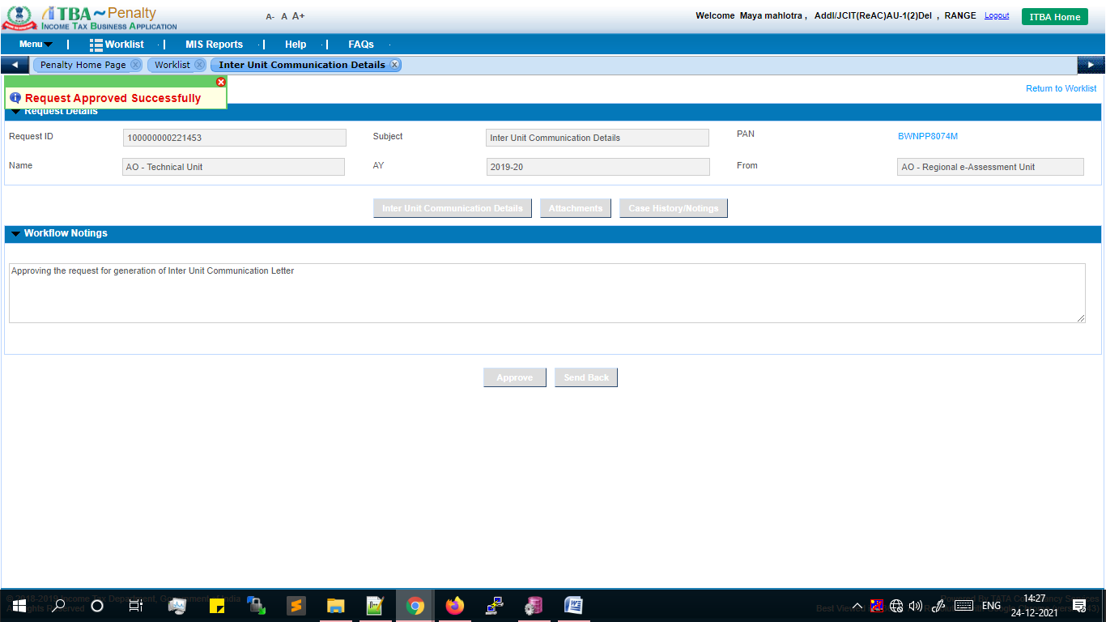

* **User: Source Unit AO**

1. Navigate to **Penalty** module.
2. Under **Menu** 🡪 **Worklist**
3. Click on **Subject** link. **Inter Unit Communication Details** workitem screen will be displayed to the user.

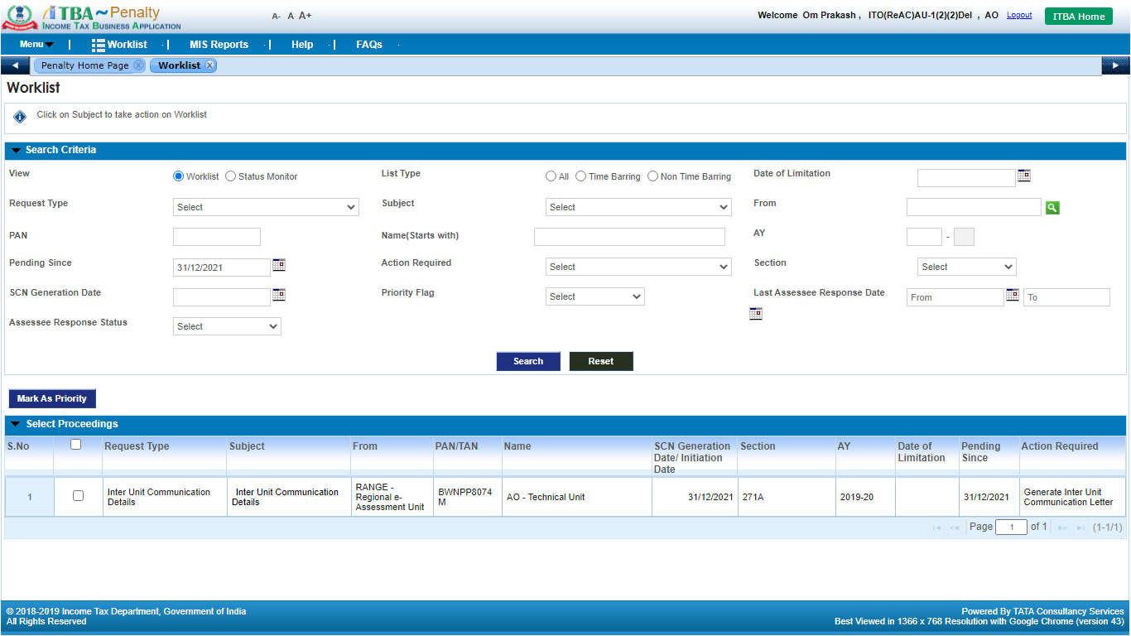

1. Click on **Inter Unit Communication Details** button.

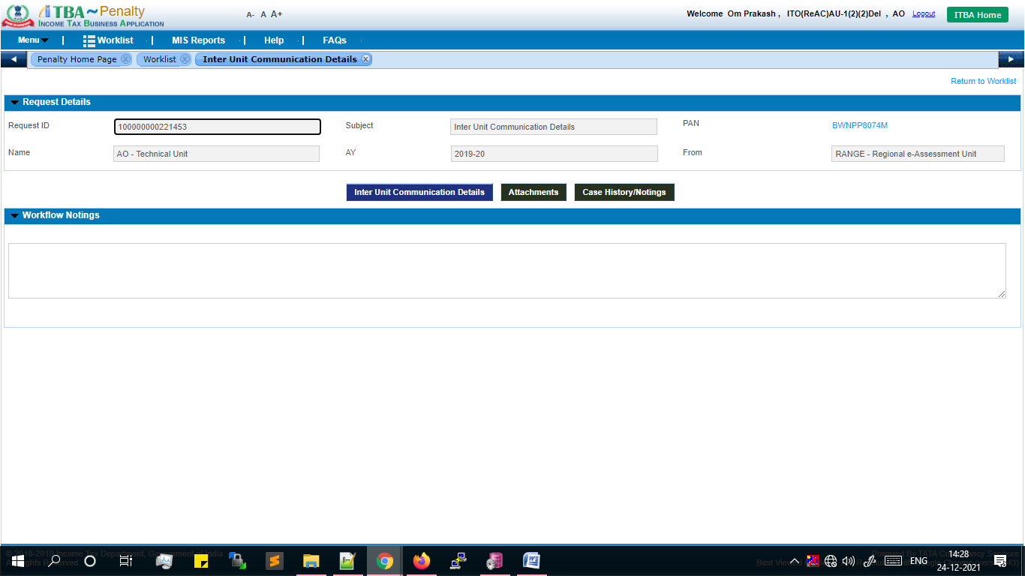

1. The Communication letter content entered by AOand updates done Range user, as the case maybe will be displayed in read-only mode.

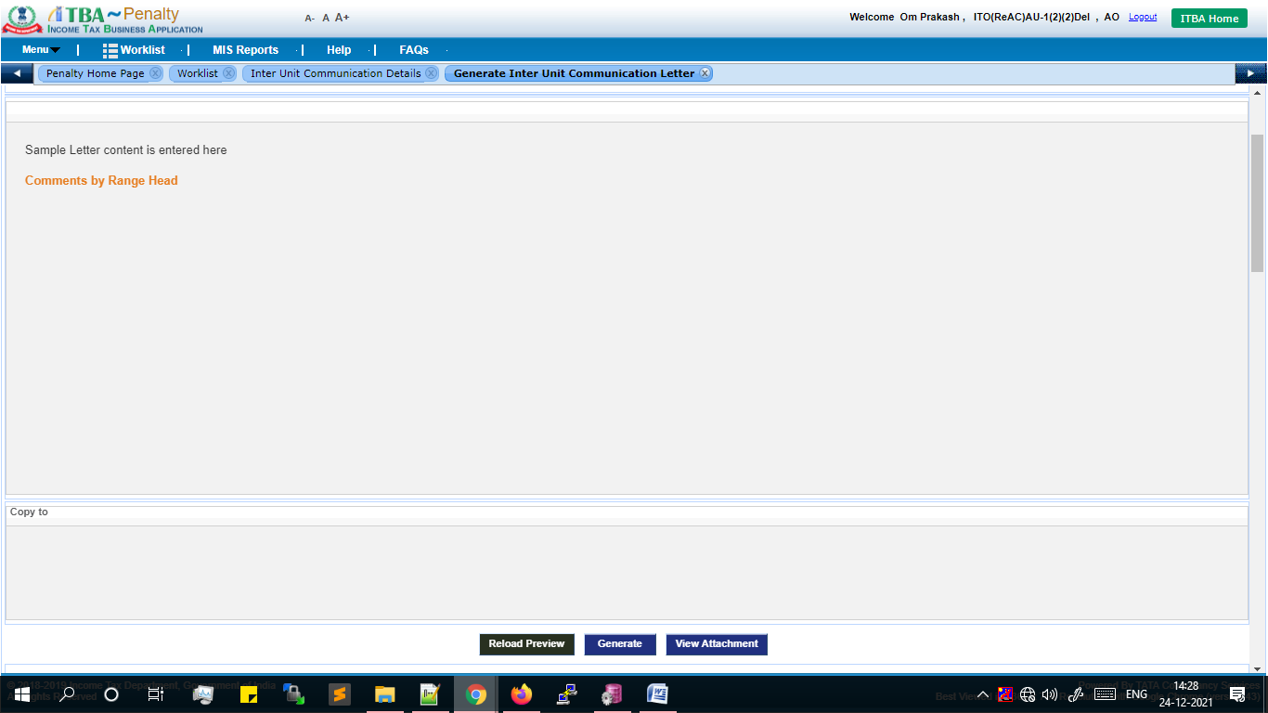

1. Click on **Generate** button to generate the Letter in ITBA system. Upon generation, a success message will be displayed to the user.

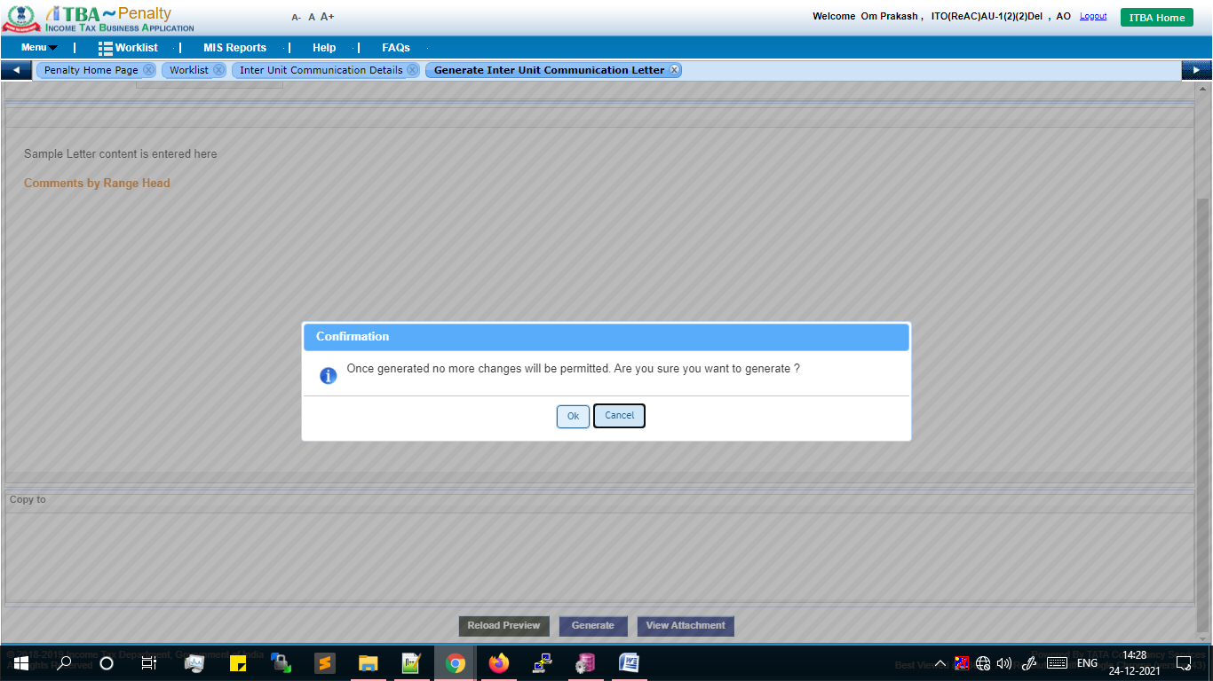

1. User will be able to download the generated Letter by clicking on **Download File Here** link. The workitem will move to destination user and will be available in Penalty Worklist.

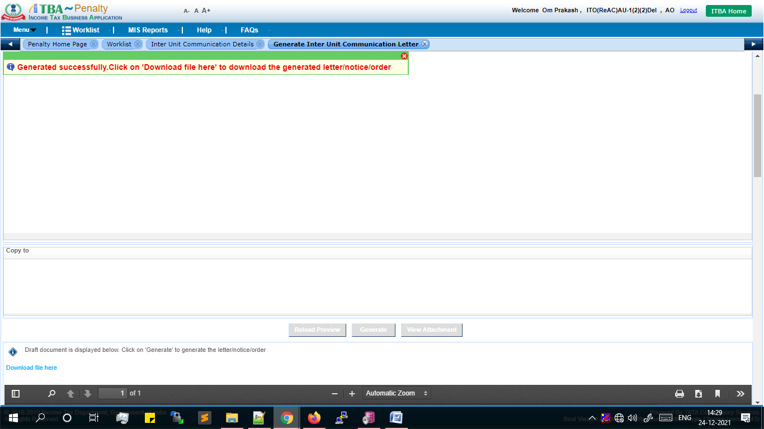

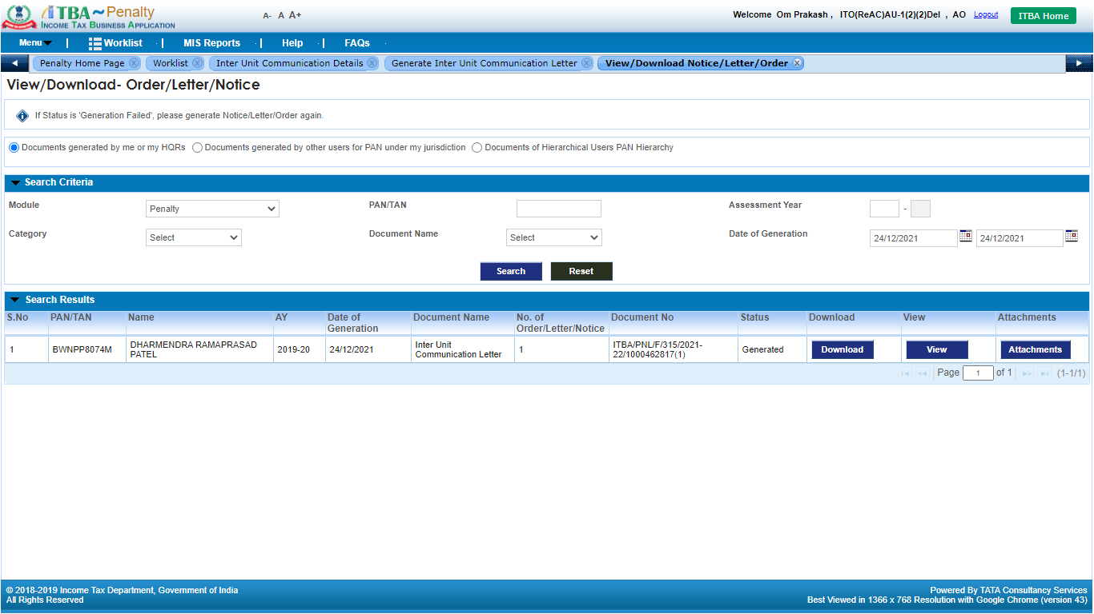

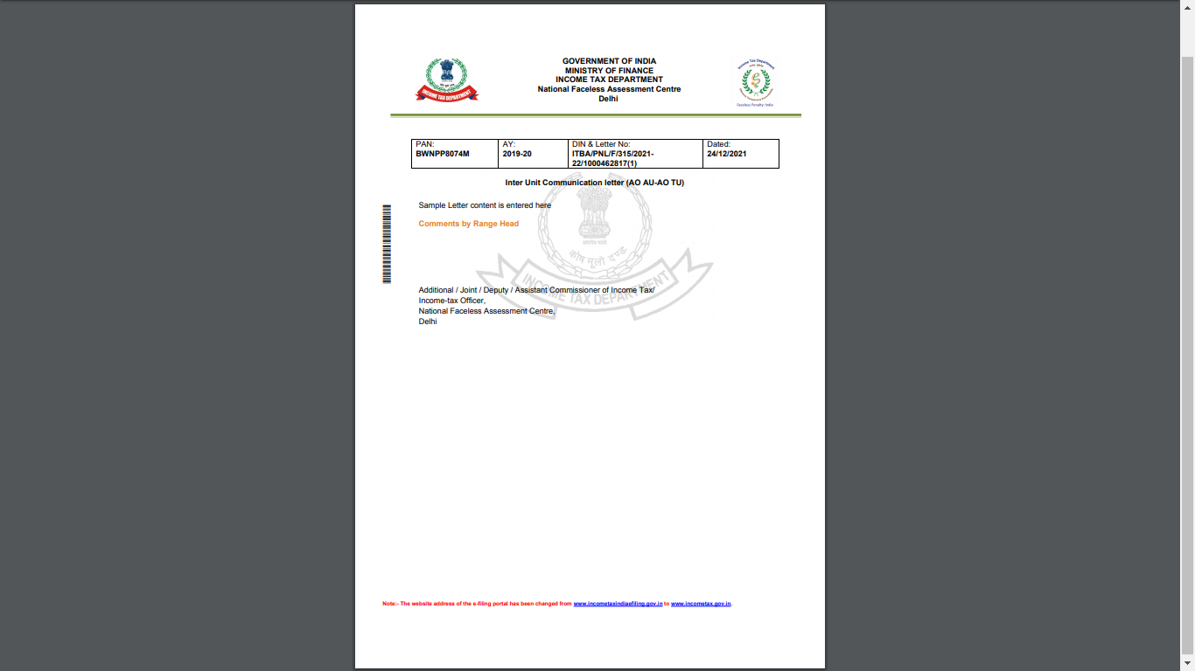

1. SMS and Alert will be sent to Destination ITD user.

* **User: Destination Unit AO**

1. Navigate to **Penalty** module 🡪 Click on **Worklist** 🡪Click on **Subject** link.

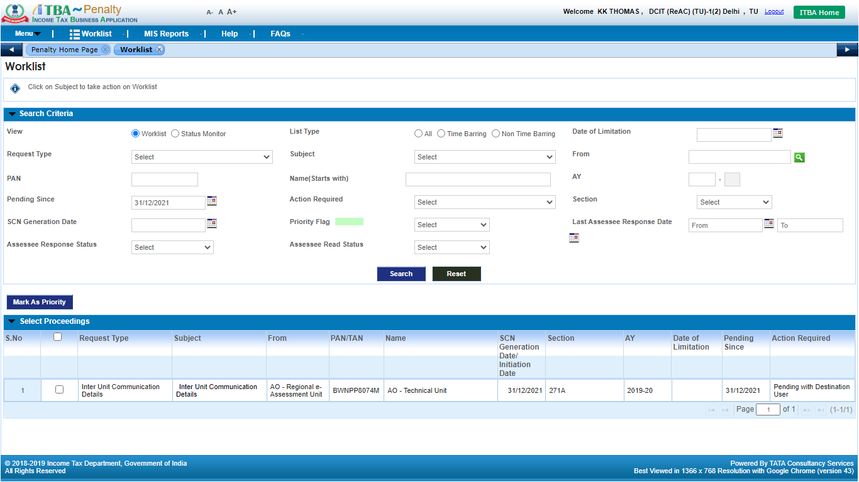

Inter Unit Communication workitem screen will be displayed to the user.

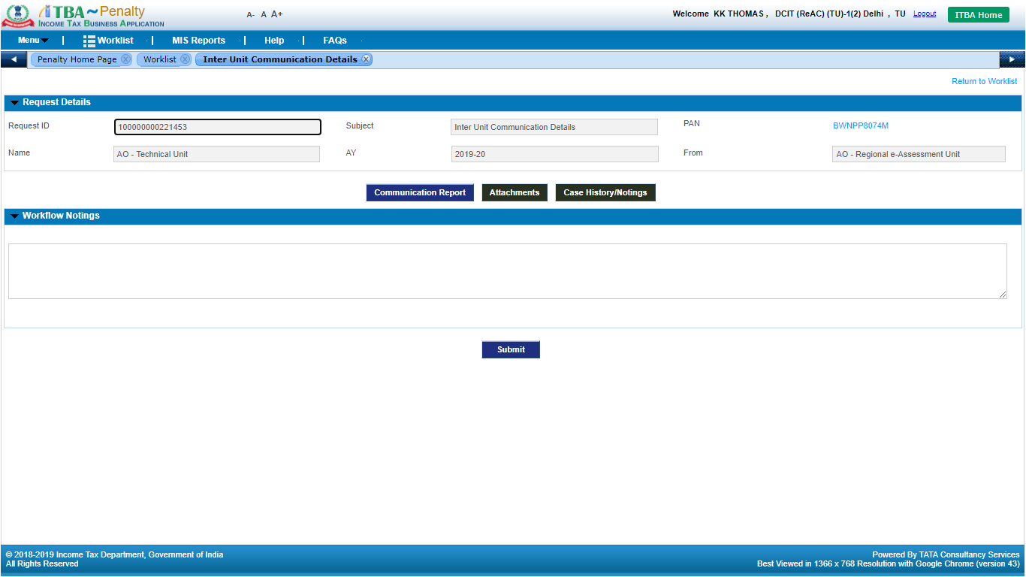

1. User can view the Letter along with supporting attachment, if any in **Case History/Notings** screen available in the workitem.

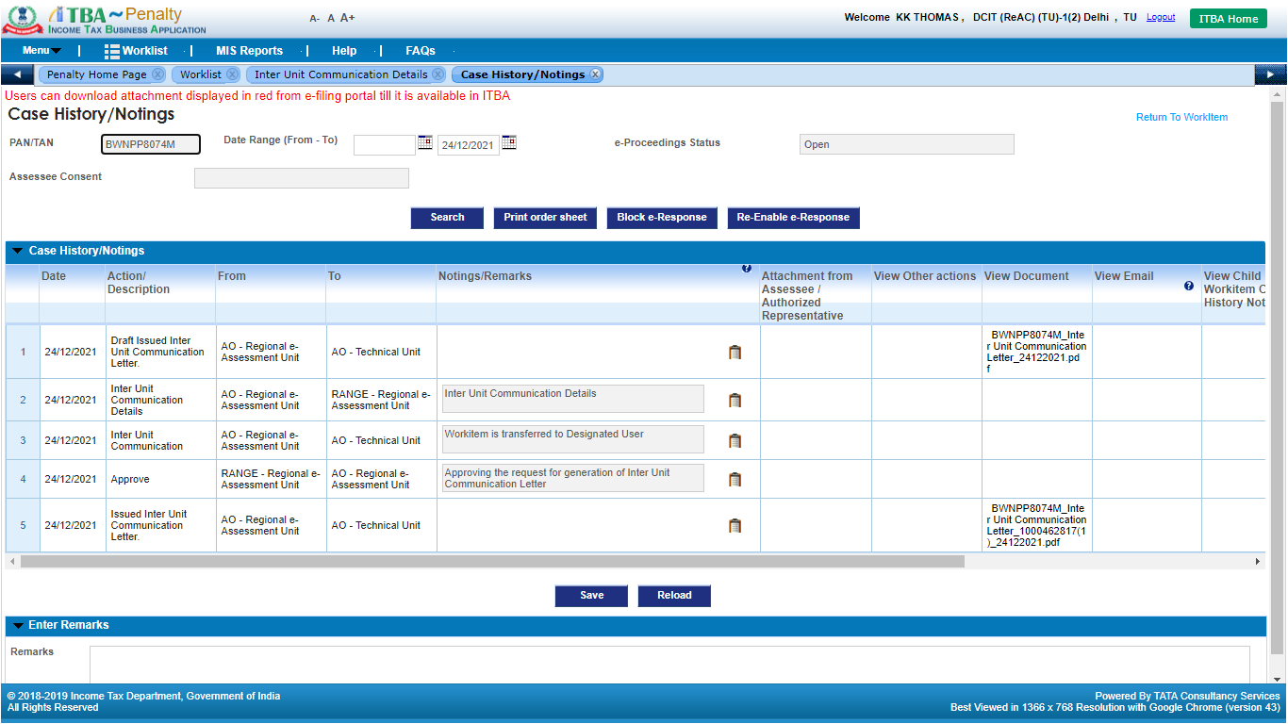

1. Click on **Communication Report** button to prepare the Inter Unit Communication Report.

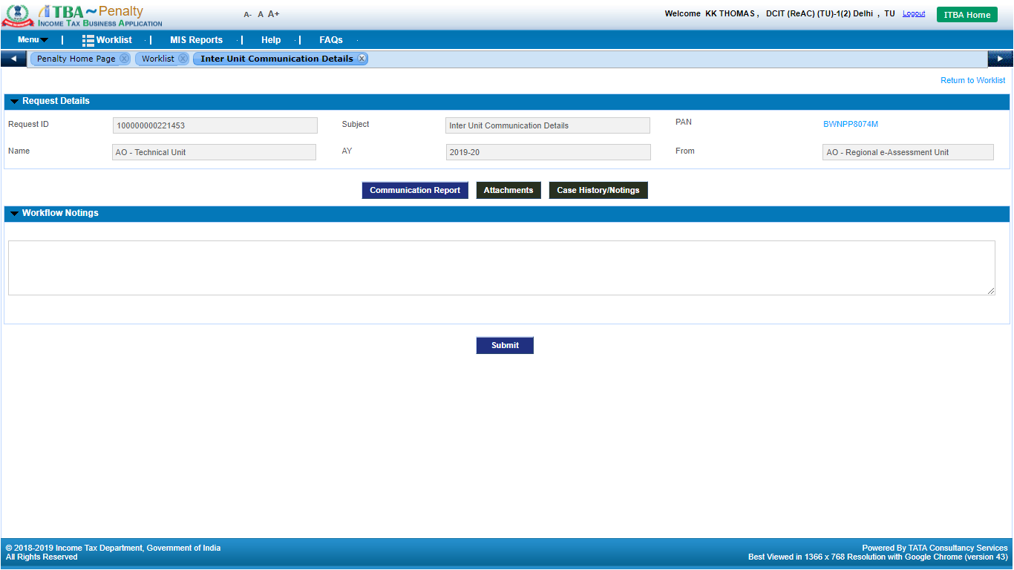

1. Enter the text to be printed in the Communication report.
2. Click on **Save Draft** button to save the details in the system.
3. Click on **Reload Preview** button to view the draft report.

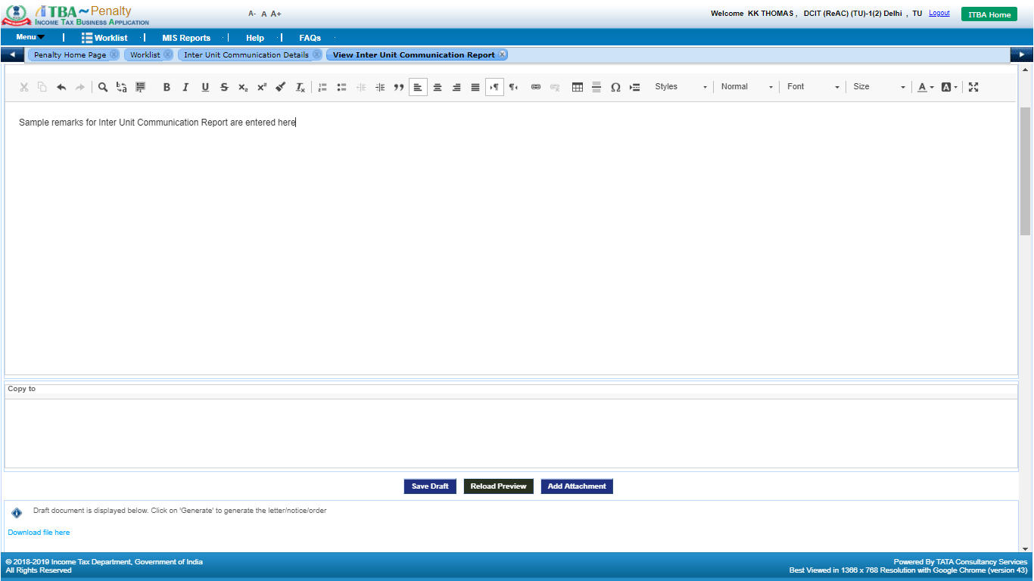

1. User can attach supporting document to be sent along with Communication Report by clicking on **Add Attachment** button and uploading the supporting document.

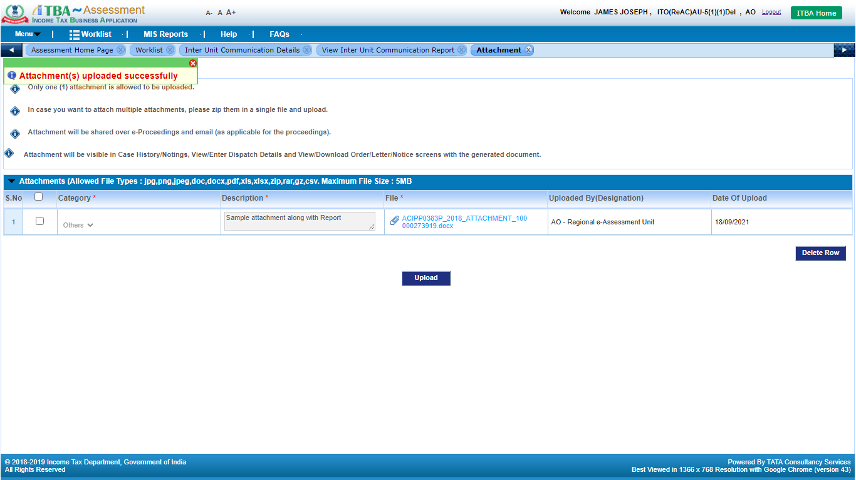

1. Navigate back to workitem screen, enter remarks in Workflow Notings and Click on **Submit** button to submit the draft request for approval to Range user. Success message will be displayed to the user regarding the request is successfully sent to Range user for necessary action. The workitem will move from AO’s worklist to Range Head for approval / action.

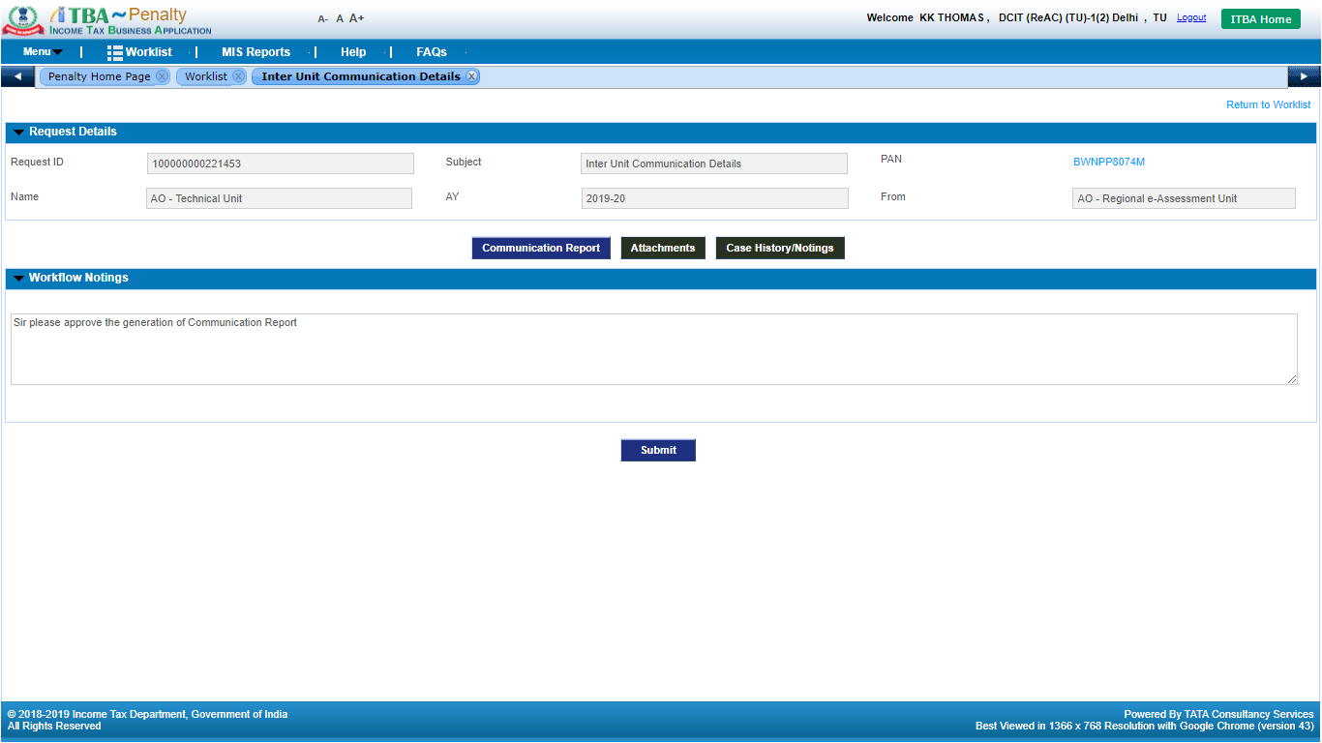

**Note:** Approval is not applicable for generation of **Communication Report** for **Range Head** and above users i.e. **PCIT, CCIT & PCCIT**.

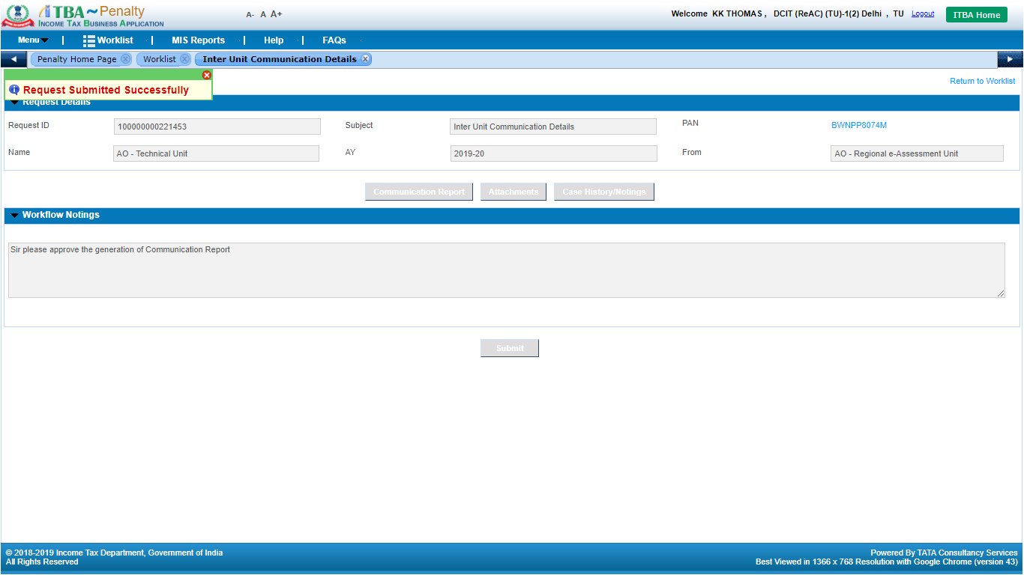

* **User: Destination Unit Range**

1. Navigate to **Penalty** module.
2. Under **Menu** 🡪 **Worklist**
3. Click on **Subject** link. Inter Unit Communication Details child workitem screen will be displayed to the user.

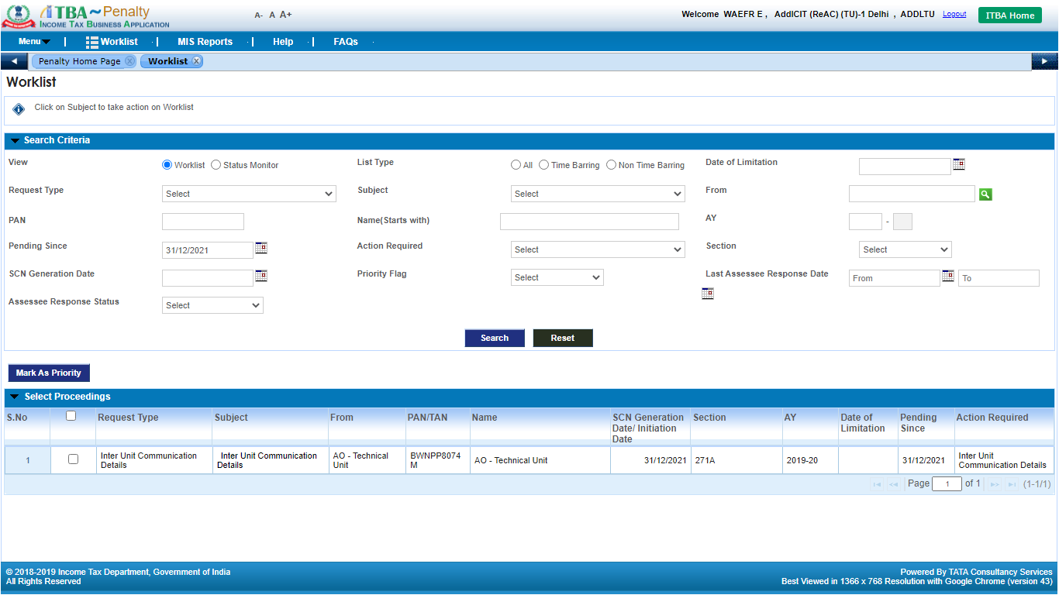

1. Click on **Communication Report** button to view the draft communication report. User can view the communication report in view-only mode.

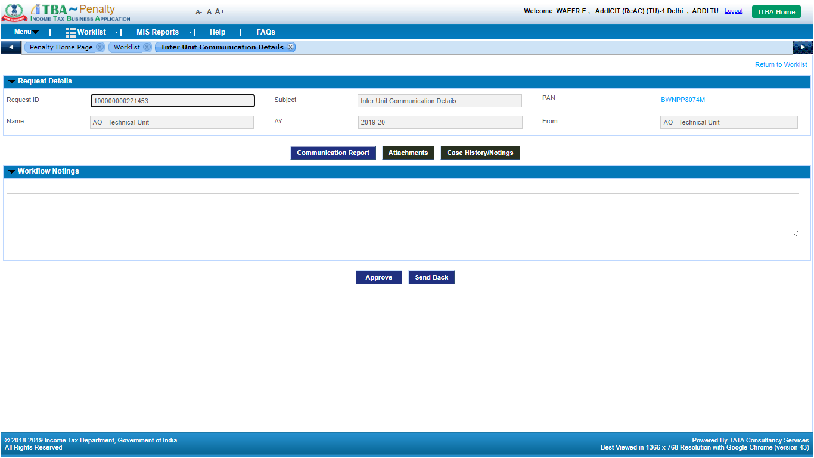

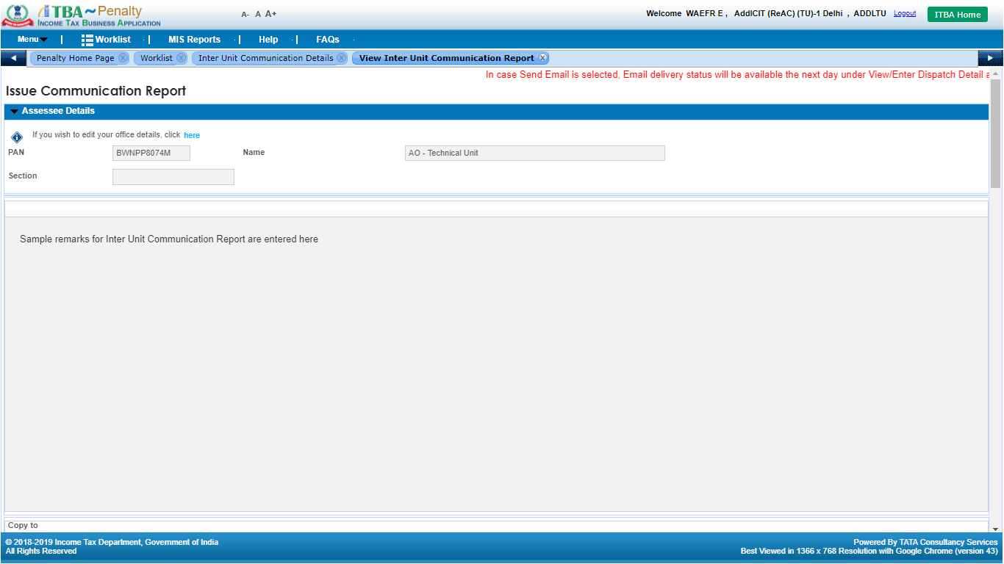

1. Range Head can take any of the 2 options:

* **Send Back**: In caseany clarification is required or report content is required to be edited through AO, Range Head will enter remarks in **Workflow Notings** andclicks on **Send Back.** The workitem will be available to AO. AO will do the necessary changes or provide clarification and **Submit** back to Range Head.
* **Approve**: In case no updates are required, user will be able to approve the generation of Communication Report in ITBA system. Enter remarks in **Workflow Notings** and click on **Approve** button. The Report generation request is approved by Range head and the workitem will be available to AO user to proceed with thegeneration of Inter Unit Communication Report in ITBA system.

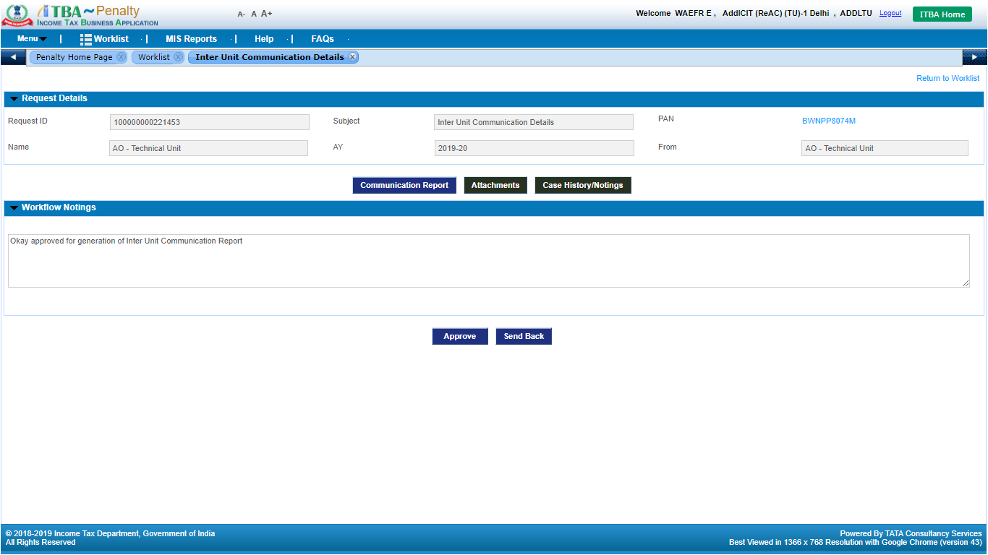

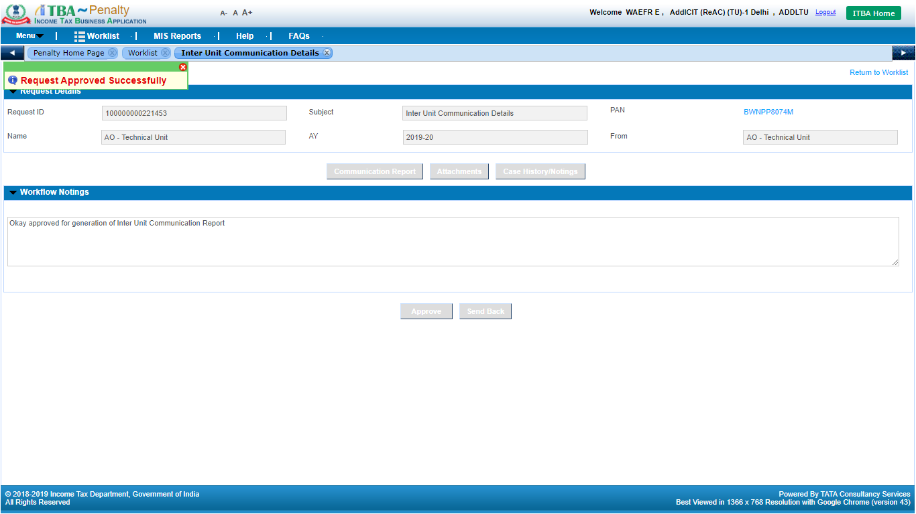

* **User: Destination Unit AO**

1. Navigate to **Penalty** module.
2. Under **Menu** 🡪 **Worklist**

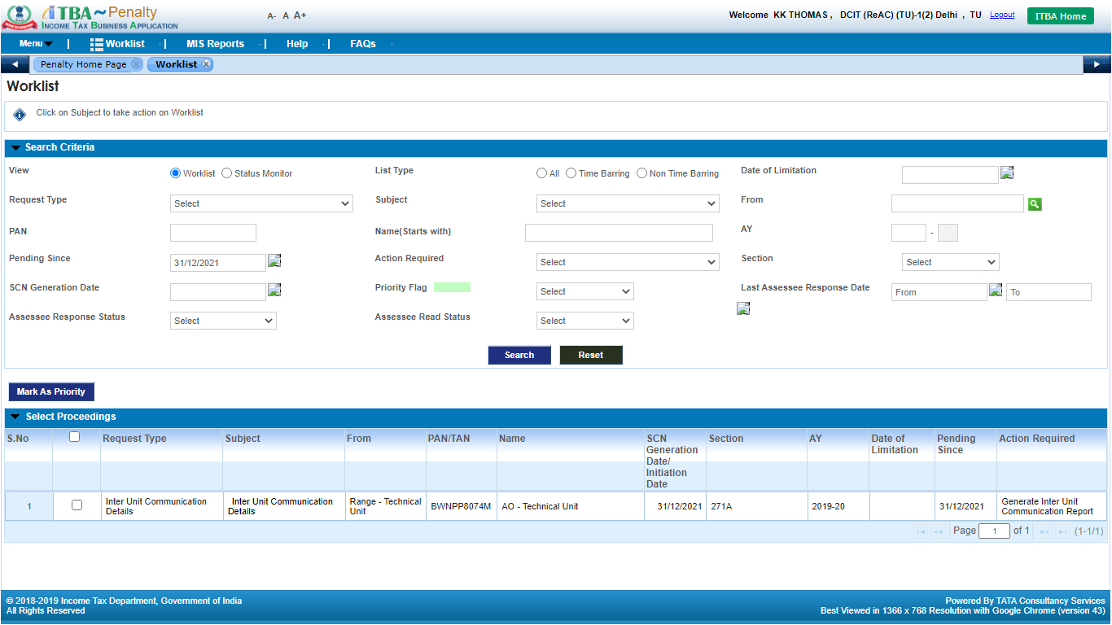

1. Click on **Subject** link. **Inter Unit Communication Details** workitem screen will be displayed to the user.

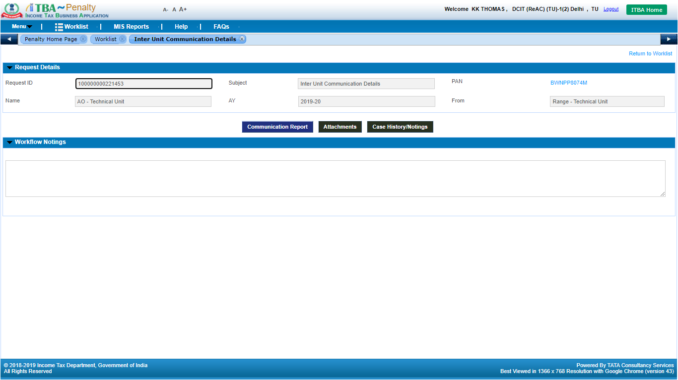

1. Click on **Communication Report** button.
2. The Communication Report content entered by AOwill be displayed in read-only mode.

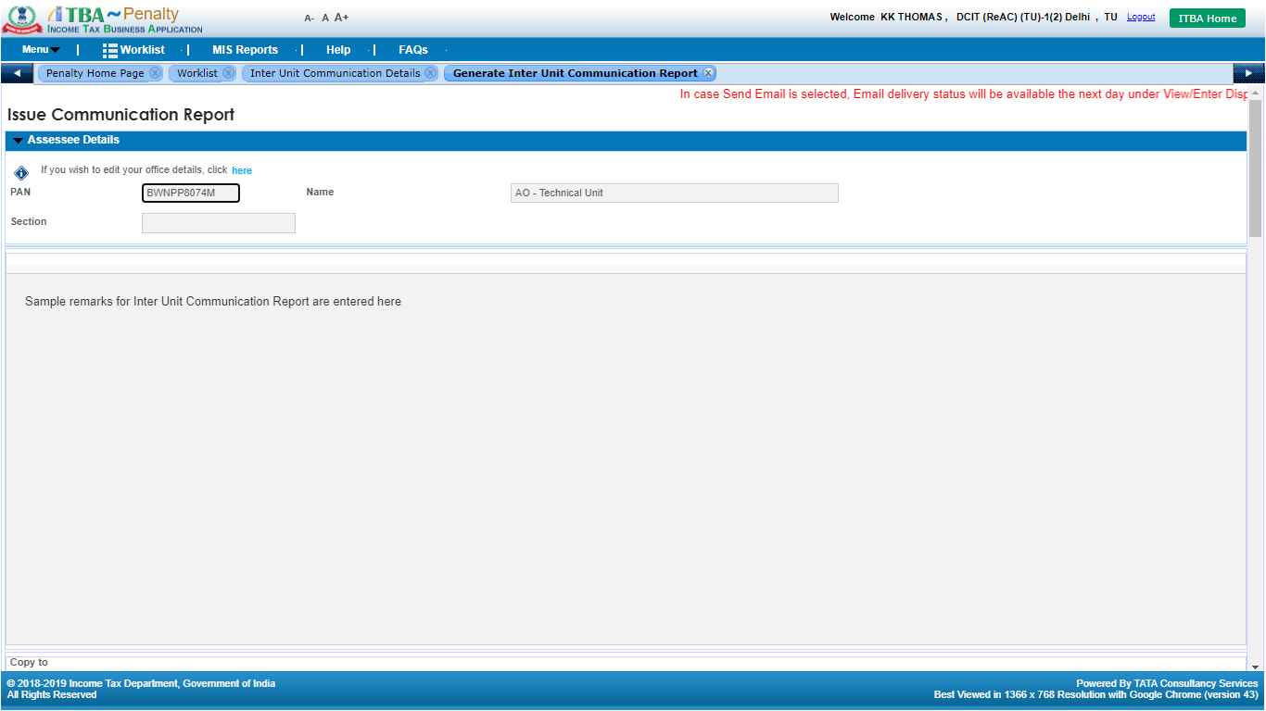

1. Click on **Generate** button to generate the report in ITBA system. Upon generation, a success message will be displayed to the user.

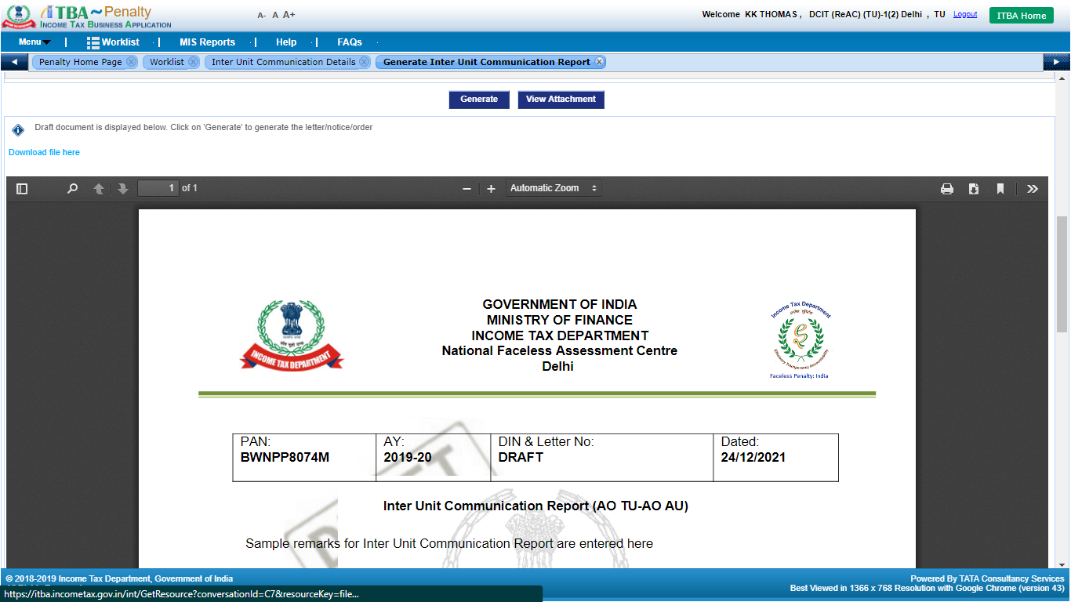

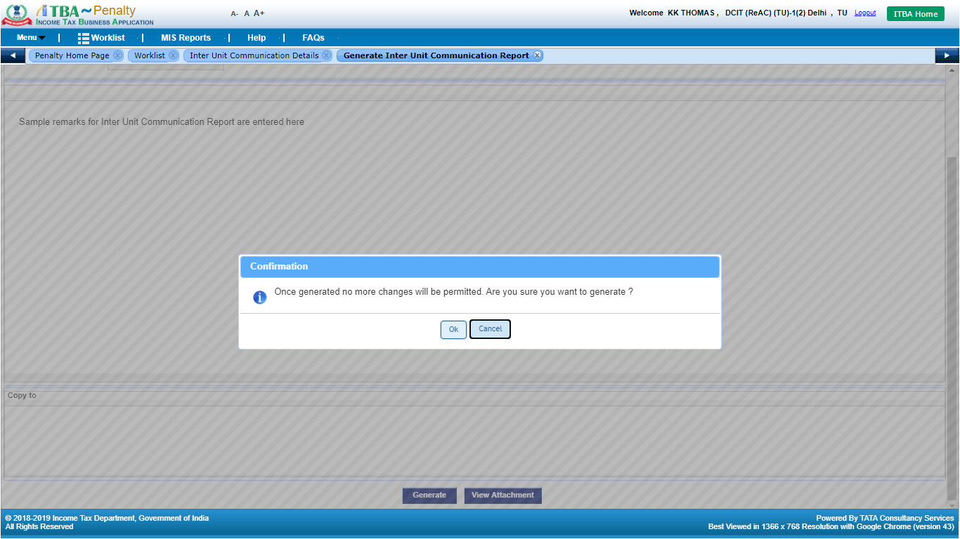

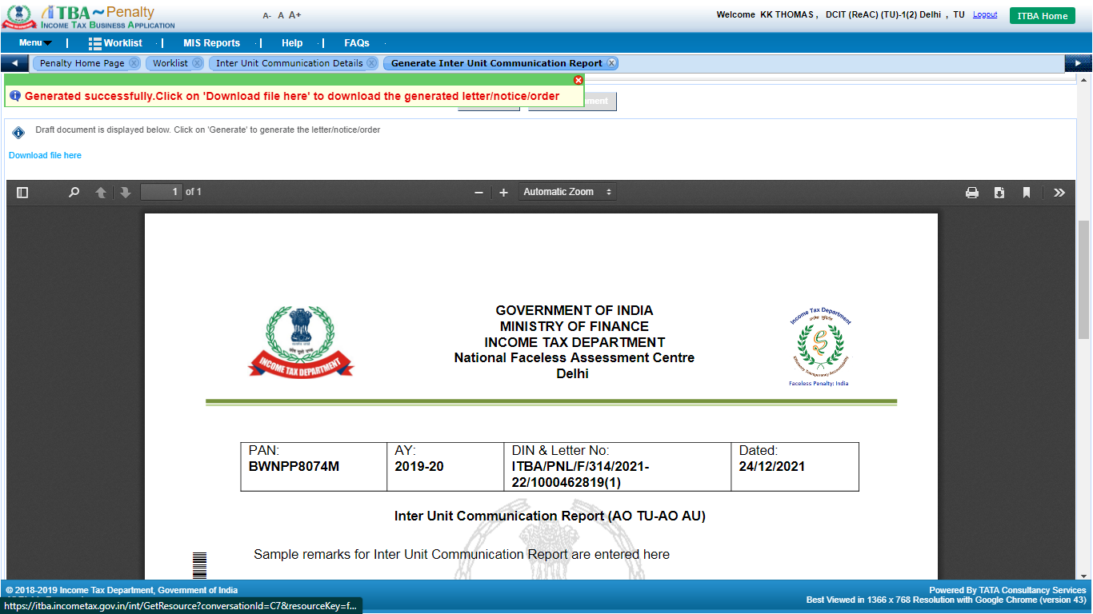

1. User will be able to download the Inter Unit Communication Report by clicking on **Download File Here** link. The workitem will move to source unit user (who initiated the request for Inter Unit Communication) and will be available in **Penalty Worklist**.

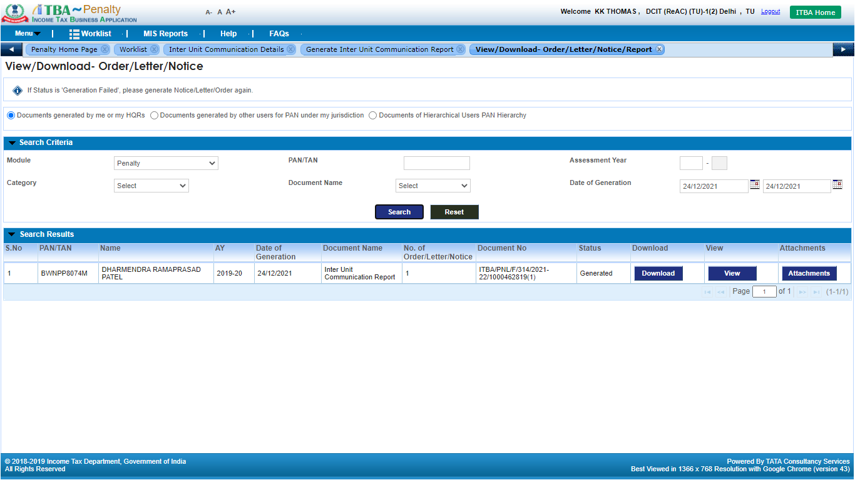

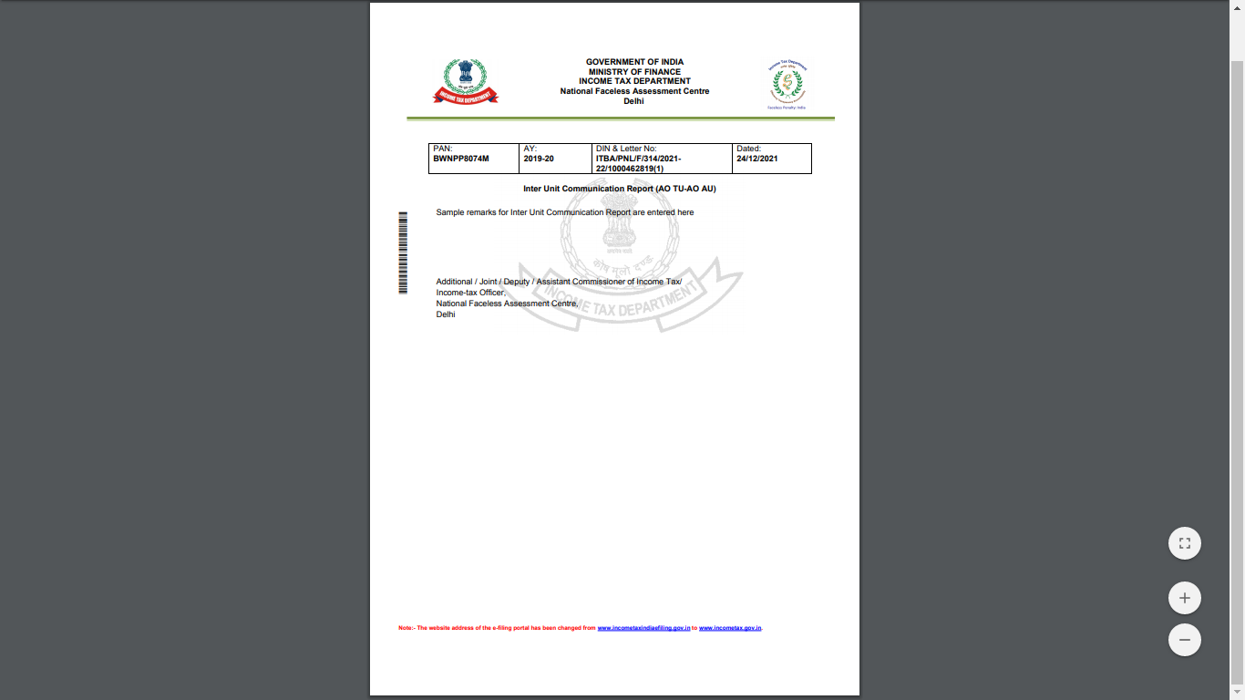

1. SMS and Alert will be sent to Source ITD user.

* **User: Source Unit AO**

1. Navigate to **Penalty** module.
2. Under **Menu** 🡪 **Worklist**

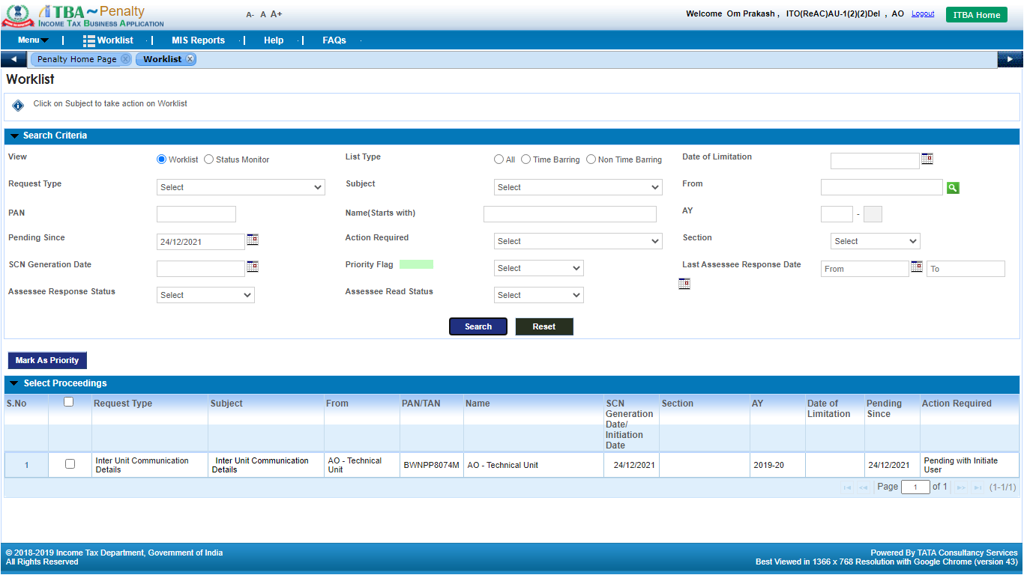

1. Click on **Subject** link. **Inter Unit Communication Details** workitem screen will be displayed to the user.

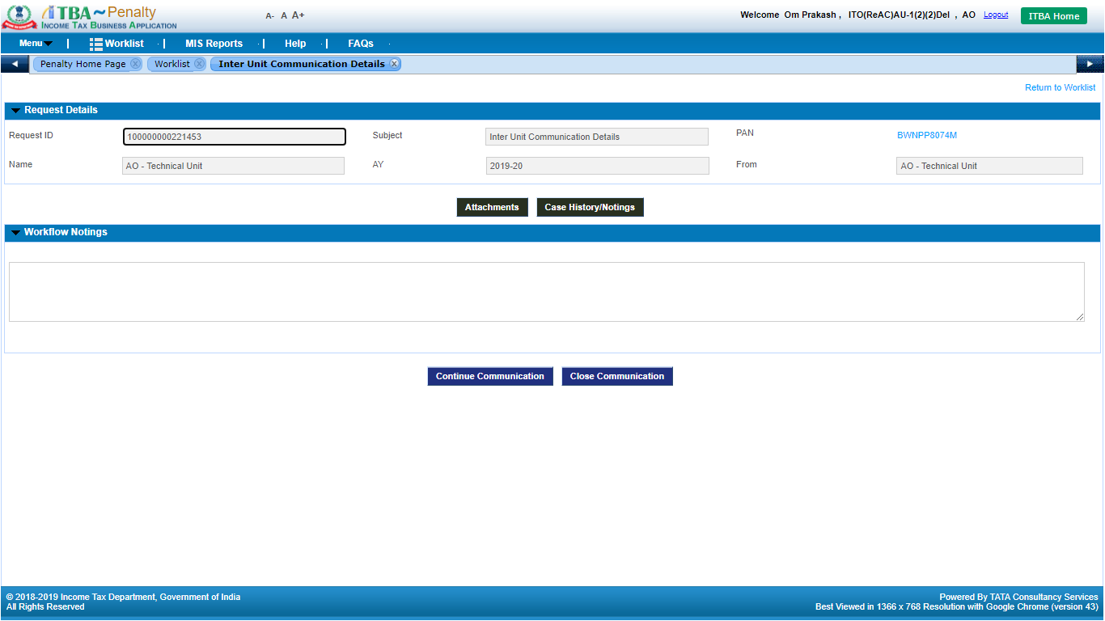

1. Click on **Case History / Notings** button to view the communication report along with supporting attachment(s).

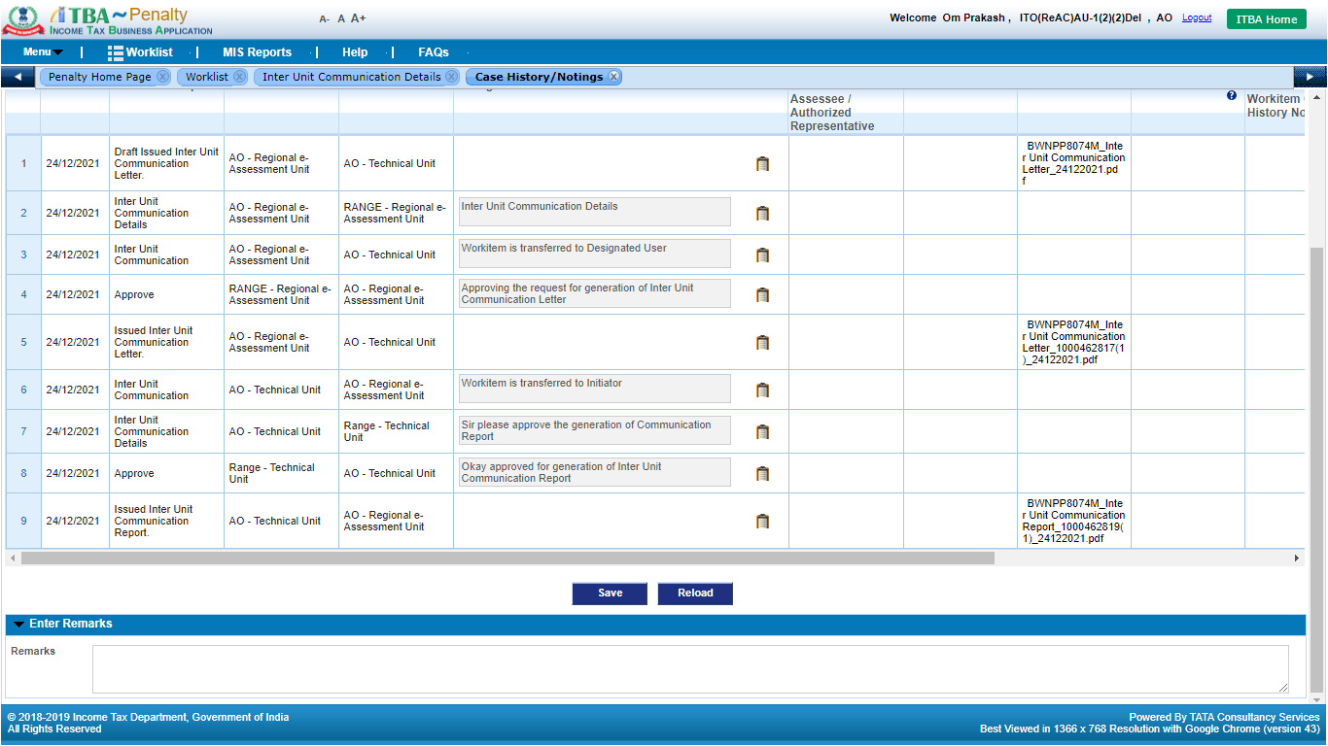

1. In case any other information is required from Destination ITD user, enter remarks in **Workflow Notings** and click on **Continue Communication**.

The workitem will move to Destination ITD user’s worklist. Destination ITD user will provide remarks in **Workflow Notings** and click on **Submit to Initiator** button. Users can also attach supporting documents in **Attachment** screen provided in workitem.

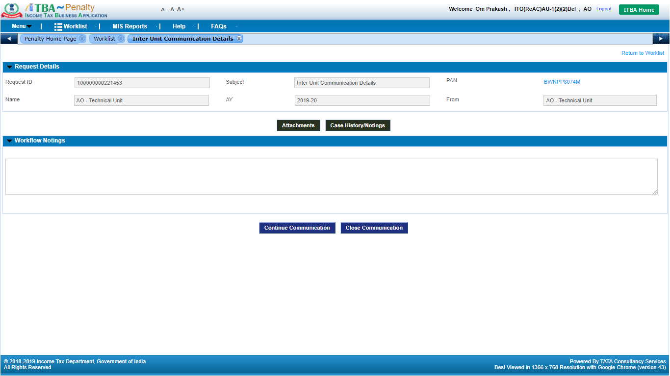

1. If necessary communication is complete, **Source ITD user** will be able to close the workitem by entering remarks in **Workflow Notings** and clicking on **Close** **Communication** button.



**Note:** The above process will be applicable to **AOs** of various units i.e. **Assessment Unit, Technical Unit, Review Unit & NaFAC**. For **Range Heads** and above officers i.e. **PCIT, CCIT & PCCIT** in various units, approval is not required for generation of Communication Letter / Report in this process.